A Conceptual Framework for Interrelations of Components of an AR-based Ubiquitous Pedestrian Navigation Service

Mohammadreza Sahelgozin ª*, Shokouh Dareshiri ^{b}, Abolghasem Sadeghi-Niaraki ^{c}
GIS Dept., Geoinformation Technology Center of Excellence, Faculty of Geodesy&Geomatics Engineering
K.N.Toosi Univiversity of Technology
Tehran, Iran
a sahelgozin@mail.kntu.ac.ir
b dareshiri@mail.kntu.ac.ir
c a.sadeghi@kntu.ac.ir

Abstract - Since there are differences in the nature of pedestrian navigation problem, current vehicle navigation systems are not proper for the use in such situations. Directions and metric instructions are not enough for an improved pedestrian navigation service, as users need salient features for orientation which are called “Landmarks”. Apart from that, pedestrian navigation systems should cover a wide range of users with various characteristics and personalities (gender, age, height, etc.) and also various “personal desires and preferences”. Such systems should also be able to provide services under different environmental situations. User and environmental conditions could be summarized from the real world with the help of “Contexts” in order to make the service more ubiquitous. Furthermore, a pedestrian navigation system, more than only providing a virtual space in mobile devices which leads to users getting confused during frequent moves between two virtual and real spaces, would be better to become supported by “AR technology” in order to provide virtual extra information in real world for pedestrian navigation purposes. In this paper, four concepts (Ubiquitous and context, AR technology, Landmark and User’s desires and preferences) in an aggregated framework are investigated for an AR-based Ubiquitous Pedestrian Navigation Service (AR-based U-PNS). Our effort is showing the interrelations of these concepts and also their importance and effects on a pedestrian navigation system. A myriad of examples have been provided to explain these effects more detailed. Furthermore, an online questionnaire survey has been performed to decide how to arrange these components in the framework suitably. Results of the interview confirm the relations provided in the framework.
Keywords— Ubiquitous, Pedestrian Navigation, Landmark, Augmented Reality, Context, Recommender System

Introduction
Popularity of navigation systems which provide a convenient service in order to help users to get to their destination has been increased during last years. Previous attempts concentrate on navigation systems of vehicles. However, the importance of these systems for pedestrians is not less than vehicle’s ones. As the nature of pedestrian navigation problem differs a lot, current vehicle navigation systems are not proper for the use in such situations. This has some reasons: for example Millonig, A. and Schechtner, K. [1] declared that pedestrians possess higher degree of freedom in comparison with vehicles. They also are able to pass through paths which are not accessible for cars. They need higher precision in positioning so that GPS equipment which is usual in cars is not satisfactory for pedestrians’ needs.
Furthermore, travelling at a lower speed than cars, pedestrian might have more time to move his mind constantly between a virtual space of a device which helps him to navigate and a real space of his surrounding environment. These facts, hence, lead pedestrian navigation systems to be totally different from those for vehicles.

Ubiquitous, context and Augmented Reality concepts
Systems for pedestrian navigation have to become specialized by two properties; first, as Gervais, E. et al. [2] emphasized the fact that pedestrians are mobile, it is necessary for them to be provided by small and portable devices. Second, such systems should cover a wide range of users with various characteristics and personalities. In addition, users have different preferences; therefore, navigation systems should also be personalized based on users’ demands and desires. Here is where ubiquitous systems can be applied.
A Ubiquitous Geospatial Information Service (UbiGIService) is able to serve any spatial service to any user by any device and any network infrastructure in any location, any time and any condition. In other words, “really ubiquitous personalized GI services adapted to the current situation (context), in order to deliver the right information in the right situation to the right person the right way” [3]. It can be claimed that firstly the meaning by the word “any user” is that the system must adapt itself to different users’ personalities and preferences which means it must be “user centric”; this means that the user is the most important component of a GI service, although there might be some conflicting tastes about the centric element of this service; for example Wang, S. M. and Chen, F. M. [4] claimed that in terms of technology, the service provided by the server is the most important element rather than user. Secondly, intention by remarking the words “any location, any time, any service, any device, any network and any condition” is the need of adaptation of the system to the surrounding environment. For this objective, it is necessary for the system to sense its surrounding environment.
The real world, if a UbiGIService tends to percept the environment, should be represented partially and approximately from an agent’s perspective which is called as “context” [5]. Contexts are described by de Paiva, V. et al. [6] as something which “support making existential statements about the existence and non-existence in specified possible worlds of entities”. So they represent the current situations and conditions.
By sensing these contexts physically (like sensing location of a user), virtually (like sensing the time by a device’s clock) or logically (like understanding that a user should be in his workplace by deducing logically from the time), pedestrian navigation service could become “context-aware”, a quality which is considered by Zipf, A. and Jöst, M. [3] as having a significant role in ubiquitous computing to realize user friendliness. In addition, the system should be capable to identify discrete objects of the world and their real and virtual properties by sensing the contexts, retrieve suitable information for user from its database and represent it in a user-friendly manner and in a way that the information, specially the virtual one, embed in user’s perspective of the real world so that extra information in user’s sight do not interrupt his perception of the real world. This is what was employed in several applications by Augmented Reality (AR) technology.
AR is the technology of merging the synthetic sensory information into a user’s perception of a real environment and the virtual objects should interact with other real objects and user in a natural way that they will have transparency [7]. Generally speaking, it is accepted academically that such technology aggregate the virtual and real information in a same space that is the real world and the process should be interactive and real-time. Hence, it can be concluded that as Azuma, R. T. [8] mentioned, AR supplements the real environment instead of completely replacing it by virtual space.

Navigation and the use of landmarks
Navigation process has two separate steps: planning and executing; the planning step consequences in some metric route instructions and some prominent spatial features which leads the user to navigate conveniently [9]. As Millonig, A. and Schechtner, K. [1] expressed, directions and metric instructions are not enough for an improved pedestrian navigation, whereas it is enough for vehicles, and users need salient features for orientation. These salient objects are usually called as “Landmarks”. In previous works some approaches were employed in order to assess different ways of pedestrian navigation such as random search, moving towards a visible cue, following a fixed instruction, associating directions with visible cues, forming a mental representation of surroundings, using road types or street names, utilizing sound instructions or sets of combination of these methods, and they finally conclude that pedestrian motivate to use landmarks [1, 10, and 11]. Also Ross, T. et al. [12] concluded in their work that using landmarks for pedestrian navigation will significantly decline user’s errors as well as dramatically improving his confidence.
Landmarks are permanent, noticeable and discrete spatial features that not only are necessary to orient and instruct pedestrian precisely, but also are important to be applied in the middle of the way before reaching to a specific point where user needs to make a new decision. This make him sure that he has come right up to here. In this regard, May, A. J. et al. [11] pointed the fact that provided information by a mobile device in a navigation system can be divided in primary information and secondary information; primary information like “turn right at the mini roundabout” is vital for leading the user and navigation might become impossible without them; whereas in contrast, secondary information like “turn left at the next set of lights, with the cafe on the corner” consist of redundant information which help the user at a point of navigational uncertainty.
Salience of a landmark can be considered as its most important feature. This salience depends on the user’s point of view, surrounding environment and other objects rather than being only a property of the landmark. However, salience is not just noticeability or visibility; it can be defined as not having ambiguity. For example Sefelin, R. et al. [10] emphasized its name should not be esoteric. In addition, suggesting a large number of redundant landmarks by a navigation service might confuse user.

Motivation
The requisite of designing pedestrian navigation services on mobile devices is, understanding the nature and duties of these services as well as information desired by users [11]. Desired information by user is usually shaped by his personality and preferences. Furthermore, user should interact with environment. Because as Zipf, A. and Jöst, M. [3] emphasized, user preferences and environmental conditions would help more accurate navigation. Therefore, in a precise navigation process, user should make bounds with his surroundings by the system in a user-centric environment.
On the other hand, some scholars believe that “vision” is the most important sensory input for navigation purposes. For example, Caduff, D. and Timpf, S. [9] believes that the basis of the sensory input is “vision”. Apart from that, Millonig, A. and Schechtner, K. [1] said in familiar areas, when a person travels thorough a path frequently, he makes a mental view of the area by memorizing the details. The importance of landmarks and the vision sensory input can be considered as requirements of shaping this mental view, especially, as Caduff, D. and Timpf, S. [9] mentioned, for someone that it is the first time he passes the route. However, other sensory inputs such as audition (like hearing the sound of a coppersmith workshop), smell (like sensing the smell of a confectionary) and touch (like sensing the pressure of the air comes out from a subway station’s enormous fan on the skin) could improve user’s perception from the environment and such contexts can be applied as landmarks in a pedestrian navigation system.
In addition, Bradley, N. A. and Dunlop, M. D. [13] based their study hypothesis on the fact that people vary individually and collectively in terms of their use of surrounding environmental objects information to navigate. Their study results demonstrate how each person’s contextual description of the environment is unique. We believe that salience of a landmark for a person is shaped by his interests and tastes. Different perceptions of the environment apart, there are some differences between individuals which are caused by gender, age, personality, characteristic, leaning, desideration and so on. In this scope, a reference to the fact that Millonig, A. and Schechtner, K. [1] quotes from (Fontaine S. and Denis M., 1999) would be helpful. They concluded in their work that men usually tend to mark two-dimensional objects such as streets and squares, with women usually attending to three-dimensional objects such as high buildings and mountains. Therefore, these differences as contexts should be imported in the design and implementation of a pedestrian navigation system.
However, contexts are not limited to user’s uniqueness. Environmental situations and conditions of the user’s surroundings such as time would affect suitability and salience of a landmark for a specific person. Therefore, such contexts should be applied in a pedestrian navigation process as well in order to make it more ubiquitous.
Furthermore, a pedestrian navigation system, more than only providing a virtual space in mobile devices which leads to users getting confused during frequent moves between two virtual and real spaces, should be supported by AR technology in order to provide virtual extra information in real world for pedestrian navigation purposes.
In this paper, four concepts (Ubiquitous and context, AR technology, Landmark and User’s desires and preferences) in an aggregated framework are investigated for an AR-based Ubiquitous Pedestrian Navigation Service (AR-based U-PNS). Our effort is showing the interrelations of these concepts and also their effects on a pedestrian navigation service. Because the design and implementation of a pedestrian navigation system is affected widely by these relations.

LITERATURE REVIEW
There is a wide range of previous studies about pedestrian navigation in terms of a service’s implementation or assessment of different factors which has effect on the system’s performance. We summarized and categorized them in two groups which are declared in following sections of this chapter.

Ubiquitous Pedestrian Navigation / AR-based Pedestrian Navigation
The study of Retscher, G. and Kealy, A. [14] reviewed newly-developed positioning technologies and integrate them in navigation systems in order to improving vehicle safety in difficult visibility conditions (e.g. by augmenting virtual road boundaries with an AR technology) and to guide pedestrians to a specific place (by tracking them with a set of sensors in an integrated system) in two different vehicle and pedestrian case studies. However, needs and preferences of the user and environmental contexts have not been applied. In addition, landmarks were not considered properly and they were limited to some tags and also system was not personalized.
Similarly, Retscher, G. and Fu, Q. [15] integrated different approaches such as RFID, GNSS and DR (Dead Reckoning) for ubiquitous positioning in pedestrian navigation. However, they did not import contexts in their work. In addition, landmarks are not chosen by various desires of different people.

Users’ behaviours diversity in Pedestrian Navigation / Landmark-based Pedestrian Navigation
The study Bradley, N. A. and Dunlop, M. D. [13] categorized all possible contextual information into nine groups. They concluded diversity of different individuals in their interaction with their environmental context in navigation purposes by performing an interview with a set of participants. Nevertheless, this study did not note the concept of ubiquity and augmented reality.
Equivalently, May, A. J. et al. [11] identified different kinds of required information by pedestrian in the navigation problem. They introduced seven kinds of information by which a pedestrian can navigate and at the end of the study, they concluded that landmarks are the most popular cues compared to other kinds of information.
On the other hand, Ross, T. et al. [12] by performing a test consisting of 40 participants, compared the amount of errors they made as well as their confidence in two different situations; first, getting instructed by means of basic instructions set and second, by means of enhanced instructions set which applied landmarks. They emphasized on the importance of enhancing route instructions using landmarks by evaluating numerical and statistical assessments.
The study of Sefelin, R. et al. [10] also emphasized on the landmarks’ significance as well in navigation process. Furthermore, they used five different approaches to deduce a number of facts such as which features can attract users to support their navigation in a crowded area or what happens if the instructions are provided for a user by sound and so on.
In addition, Millonig, A. and Schechtner, K. [1] also performed an approach to extract possible landmarks which can be applied in a navigation service for pedestrians in a train station. They perpended in people’s trajectory in a station and extracted decision points where pedestrians used to stop. They excluded ticket machines or escalators or something like that from these decision points set. Then, passengers were asked some questions to understand which landmarks are often used in these decision points and they finally applied these landmarks to make all instructions needed between all possible origins and destinations in the station.
At last, Caduff, D. and Timpf, S. [9] presented a computational approach for assessing a landmark’s salience. They introduced a three-dimensional vector which its elements are Perception, Cognition and Contextual salience. They discussed about different factors influence each element of the vector and they proposed a model by which a salience assessment process can be done.
At the end of chapter 2, it should be noted that the above categorization might not be as so discrete as mentioned and some studies which described in a group may belongs to the other group as well; in other words a study could belongs to both categories.
According to the literature, there has been no integration of ubiquitous space concept, AR technology and emphasis on importance of landmarks and also user’s preferences in the design and implementation of a navigation system for pedestrians yet although they are widely needed. In next chapter, a framework to approach such integration is proposed by showing how importance each component would be as well as how they would affect the process of a pedestrian navigation.

PROPOSED FRAMEWORK
In this study our effort is making an integration of four technologies and concepts and showing their interrelationships in order to know how these concepts affect the process of a pedestrian navigation system. These four main components are:
- UbiGIServices and Context concepts
- AR technology
- Landmarks
- Users’ desires and preferences
Each of these components consists of finer elements. In pedestrian navigation purposes, these elements influence quality of other components. Hence, it is important to consider these components and their interrelations. Aggregated components, their finer elements and effects of these components on each other are considered in a framework which is shown in Fig. 1.
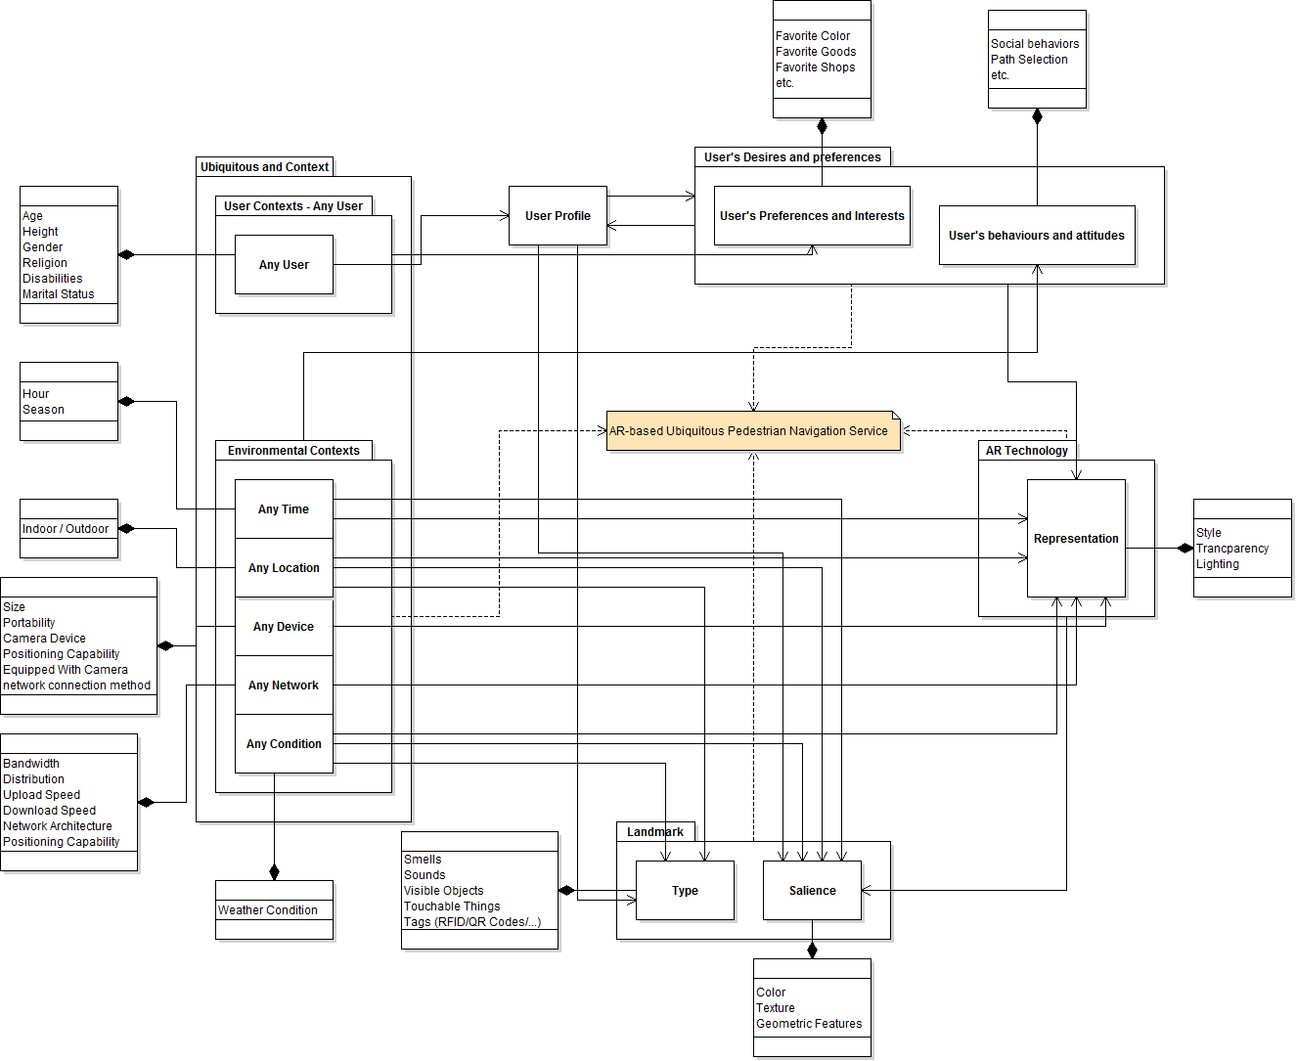
Fig. 1. Proposed framework: An AR-based U-PNS components and their interrelations
The following sections of this chapter have been assigned to have a more detailed look at these four components and their finer elements. A number of examples have been provided to explain relations between components of the framework.

UbiGIServices and Contexts concepts
As it has been reviewed in section 1.1, a ubiquitous server has to present the service regardless to the “time”, “location” and “condition” in which the service is being provided and to the type of the “device” or “network” by which the service is being provided and also to the “user” to whom the service is being provided. We considered the time, location, condition, device and network as “Environmental Contexts” and the user’s characteristics as “User Contexts”. These contexts are composed of a set of more detailed elements.
As it can be seen in Fig. 1, all environmental contexts can affect the way in which AR technology represents extra information. Time of the day (e.g. different lighting conditions need different representation styles; some studies have been performed in this scope such as [16]), season of the year (e.g. because background of the scene is rather yellow in autumn compared to the same scene’s background which is rather green in summer, the visualization parameters should differ) and the device which provides the service for the user (e.g. different screen sizes should utilize different alignments and diminishing techniques) would influence the quality of augmenting virtual objects in the real world as well as the network infrastructure has been applied (e.g. the size of augmented information should be proportional to overcome network limitations) and weather condition (e.g. it is important to highlight objects for user in fog).
Environmental contexts also influence the salience or the type of landmarks. Time of the day (e.g. an open shop during the day would be more salient than the same shop at midnight that is closed between a set of closed shops), season (e.g. a temporary stall during a festival could be a landmark), location of the user (e.g. indoor navigation would be helped by RFID and QR-Code tags or Wi-Fi access points rather than using a building as a landmark) and weather condition (e.g. a salient landmark might not still be salient in a foggy day) may affect the suitability of a landmark. In addition, contexts such as smells (e.g. odor of a confectionary) and sounds (e.g. voice of a coppersmith workshop) and touchable things (e.g. strong air flow brought out through a subway station’s enormous fan) could be applied as landmarks in pedestrian navigation system.
In addition, environmental contexts such as time of the day (e.g. a user would choose a safer path at midnight rather than choosing the shortest path) and weather condition (e.g. a pedestrian would be more convenient while passing through a covered market while it is raining; even though it may be more time-consuming and crowded) affects the user’s desires and behaviors.
On the other hand, a user profile can be considered to gather information about user’s characteristics (age, gender, etc.) as well as his preferences. Therefore, this profile is influenced by user contexts and user’s desires and preferences while it influences user’s desires and preferences as well. User profile also have effects on the type of landmarks or their salience. For example, user’s gender, age and marital status would change things which are interesting for him/her. In addition, height of a user (e.g. visibility of a landmark from his point of view), religion (e.g. churches or mosques would attract someone’s attention more than other people) or disability of a person (e.g. a blind and a deaf person would need different landmarks) might have effects on his taste to choose a landmark which is salient for him, while it might not be salient for others.

AR technology
AR technology has a number of major functions. Representation as the most important function in this study, influences the salience of landmarks. AR can highlight some real features by some ways such as changing the color of the object which is going to be a landmark in order to make visual contrast. For example, if a person wants to reach to a market which is located next to the fifth pole from his current location, representing the fifth pole in red style on a mobile phone’s display or a Head Mounted Display (HMD) might help him more in comparison to express something like “The market is located next to the fifth pole.”
Another example could be where AR technology is able to diminish further landmarks and represent only nearer landmarks from the user’s point of view so that he would not become confused because of the redundant landmarks. In addition, nearer landmarks would be more salient for him.

Landmarks
Landmark is considerably important in pedestrian navigation purposes. Types, salience and selection of landmarks are influenced by other components. Importance of landmarks and examples for effects of other components on landmarks has been explained in chapter 1 and other sections of this chapter.

Users’ desires and preferences
User’s preferences, although can be considered as user contexts (one of the elements of “UbiGIServices and context concepts” component), is given as a separate component in the framework. The reason is the differences between it and what is introduced as user contexts. User contexts, can be believed as specifications of a user which lead to him being in a category in which similar people would stand. Such specifications might be for example “male”, “youngster”, “tall”, etc. These properties usually cause people who are in the same category to behave similarly. In contrast, user’s interests and desires are based on his personality and two individuals with the same age and gender might have different interests. Even these desires for a specific person might change based on situations and conditions over the time.
User’s desires and preferences affect the landmarks’ salience and suitability for being applied in pedestrian navigation system. Being interested in a specific good which is sold by a specific type of market, a user might consider that market as salient than others. If a person was a fan of cars, the markets which exhibit cars would be more salient for him. Hence, a navigation system should suggest it as a landmark for this user rather than common landmarks which may not be so attractive to get his attention.
In terms of implementation, a profile can be created by users of a ubiquitous pedestrian navigation service in which they can declare their interests and tastes by answering some question in order to inform the system which spatial features would be more salient for them and consequently, the system will be more personalized for each user.

Combination of elements
It has been talked about elements of each component of the framework in previous sections separately; however, they can be combined with each other to improve the system’s performance. The idea is that to increase the number of possible landmarks by such combinations. Consider the situation that the smell of a restaurant is a landmark. To instruct a pedestrian, he can be told: “you have to turn into the street at the start of which the smell of pizza can be sensed” in the situation that the restaurant cannot be seen conveniently. Although this smell as a context could be applied as landmark in navigation instruction, it can be respired during specific period of times. Here is where the time as another context should be taken into account. Therefore, time and smell would be combined for navigation service to be able to suggest more landmarks (Fig. 2).
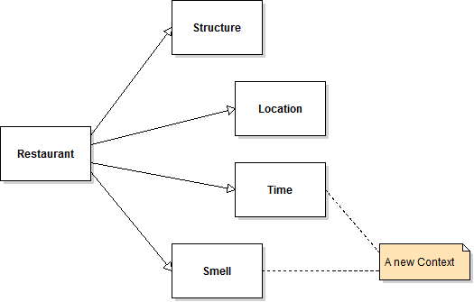
Fig. 2. Improving number of possible landmark using contexts:
Combination of time and smell as two separate contexts can be used to create a new context
Another situation where such combinations would help a user, is where the system is expected to suggest landmarks exactly when they can be seen by the user’s point of view. First, the system should highlight only landmarks which are in the route between origin and destination of the user or can be seen by him while he travels in the route. Second, the user might not need to be informed about all these landmarks during the whole journey; conversely, a landmark should appear on the display as it becomes visible for user by consideration of his height and location.

RESULTS OF THE QUESTIONNAIRE SURVEY
In this study an online questionnaire survey was done to understand how important four components of the framework are to be taken into account as well as deciding how they are related to each other. There were 76 participants from different countries who attended the test. This survey has been created and performed on http://www.kwiksurveys.com.
Main objective of the survey was extracting the tightness of four major components of the framework and their interrelations. The importance of contexts and ubiquitous component was assessed by two questions each of which asked the participants to choose at most 5 spatial features from 12 options that attract their attentions most and will help them to find their ways in unfamiliar routes. The first question was for walking during the daytime and the second was for walking at night. These 12 options and also answers of participants to the first question can be seen in Fig. 3. Participants believe that some salient objects in daytime would not still attract their attention in the dark. For example, 55.7% of participants chose “Parks and gardens” as salient object during the daytime, whereas 23.1% chose it for night. On the other hand, AR technology is also important, because it will help user to overcome difficulties to find a landmark shown on the device and not to pass it in the real world without recognizing it; this is what 74.2% of participants stated that usually happens when they are instructed in navigation. However, 65% of participants said that they prefer to be led by usual navigation systems which are currently used in mobile devices and provide route instructions rather than using a pairs of sunglasses which provide extra information in front of their eyes (25%) or asking from other people (10%) to find a route.
Furthermore, the requisition of landmarks in pedestrian navigation has been emphasized in chapter 1 and 2; hence, it is necessary to consider it as a major component of the framework. Number of possible landmarks would be increased by considering other types of landmarks such as smells, sounds, touchable things and tags rather than only visible objects. 41.1% of participants said that there are constant voices like hullaballoo of a school or a coppersmith workshop which they can hear on the way to workplace or university every day. At last, user’s desires and preferences component has been added to the framework, because results of the questionnaire show that different people even from the same gender and age group are attracted by different objects. The diversity of chosen options by different participants is shown in Fig. 3.

CONCLUSION
To sum up, in chapter 3 a framework in order to integrate four concepts and to show their interrelations was proposed. The main purpose of this study was introducing the importance of considering these concepts in a navigation service, because of the fact that their interrelations might influence output quality of the service. Then, in chapter 4 results of the online questionnaire survey was provided.
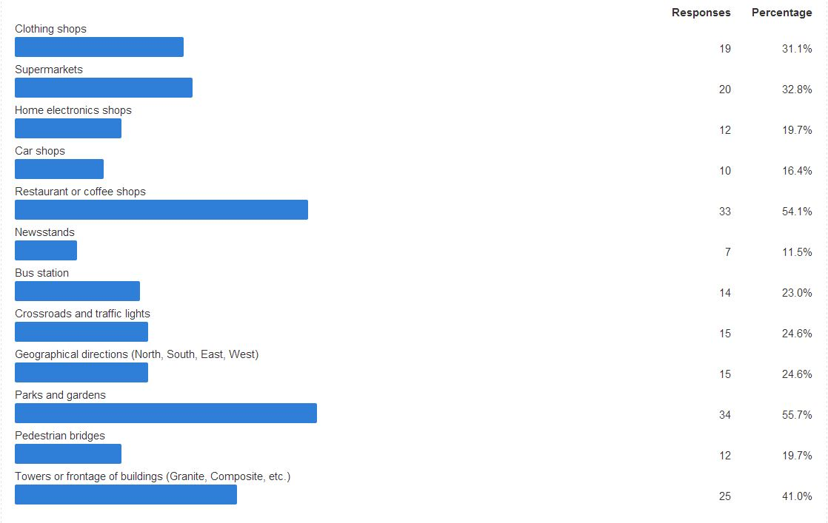
Fig. 3. Diversity in spatial features which attract different people’s attention: Different gender and age groups are attracted by various features

Finally, a brief discussion on the results will be expressed in this chapter as well as limitations of the proposed framework and also possible future works which could be performed based on this framework.

Discussion
Diversity of landmarks chosen by different participants might show that what was chose by an individual could be considered as a landmark which is specialized for him. The idea is that by consideration these personal salient objects in a street which have not enough salient landmarks such as tall buildings, the number of possible landmarks can be increased.
Results of the survey also show that people from the same gender and age group are usually interested in similar objects. For example, aged people usually remember newsstands and supermarkets, while the youth are usually attracted by parks and gardens. Also, women usually seek clothing stores, while in contrast, men’s attentions are caught more by home electronic shops and car shops. However, each individual from the same gender and age group might also has extra interests which are not interesting too for other individuals. Hence, it seems to be important to apply both user contexts and user’s desires and preferences (aggregated in user profile) to personalize the navigation process as much as possible.
Furthermore, only one fourth of participants prefer to use a pairs of sunglasses which provide extra information in front of their eyes to help them in navigation. This low percentage can be due to the fact that people might not so familiar with AR technology. Otherwise, augmenting virtual information in real world would be more helpful than creating a virtual space in which navigation service is going to be provided.
However, in general, results of the survey confirms the importance of the proposed framework’s components and the interrelations which are mentioned in the framework. These components are necessary to be taken into account in an improved pedestrian navigation service.

Limitations and future work
The effort of this study was to show interrelations of four components in an AR-based U-PNS. However, it might be incomplete and some other improvements may be needed. In this section we declare these problems and suggest future solutions to overcome these limitations.
Proposed framework might be improved by importing other components in order to develop it so that it could provide the dos and don’ts of a pedestrian navigation system’s design in which user may apply other sources of travelling such as buses and subway.
Furthermore, trajectory of a user can be considered in user’s desires and preferences component or even as a new component in order to develop the framework to become compatible with a recommender system design and implementation. This developed framework helps the system to extract user’s interests such as “season shopping behaviors” or “time of the personal travels and sports activities” and so on from his trajectory rather than asking to create his profile. Therefore, this recommender system would suggest routes suitably according to the environmental context (for example time).

Refrences

- Millonig, A. and Schechtner, K. “Developing Landmark-Based Pedestrian-Navigation Systems”, Intelligent Transportation Systems, IEEE Transactions on, 8(1), pp. 43-49 (2007)
- Gervais, E., Liu, H., Nussbaum, D., Roh, Y. S., Sack, J. R. and Yi, J. “Intelligent map agents - An ubiquitous personalized GIS”, ISPRS Journal of Photogrammetry and Remote Sensing, 62(5), pp. 347-365 (2007)
- Zipf, A. and Jöst, M. “Implementing adaptive mobile GI services based on ontologies - Examples from pedestrian navigation support”, Computers, Environment and Urban Systems, 30(6), pp. 784-798 (2006)
- Wang, S. M. and Chen, F. M. “The Development of a Ubiquitous Geographic Information Service by Using Service-Oriented Architecture”, IEEE Asia-Pacific Services Computing Conference, Yilan, Taiwan, pp. 453-457 (2008)
- Bouque, P. “Contexts and ontologies in schema matching”, The 3rd International Workshop on Contexts and Ontologies: Representation and Reasoning, Denmark, pp. 20-31 (2007)
- de Paiva, V., Bobrow, D. G., Condoravdi, C., Crouch, R., Karttunen, L., King, T. H., Nairn, R. and Zaenen, A. “Textual Inference Logic: Take Two”, The 3rd International Workshop on Contexts and Ontologies: Representation and Reasoning, Denmark, pp. 32-41 (2007)
- Vallino, J. R. “Interactive Augmented Reality”, Ph.D. thesis, Department of Computer Science, University of Rochester (1998)
- Azuma, R. T. “A Survey of Augmented Reality”, Presence: Teleoperators and Virtual Environments, 6(4), pp. 355-385 (1997)
- Caduff, D. and Timpf, S. “On the assessment of landmark salience for human navigation”, Cognitive Processing, 9(4), pp. 249-267 (2008)
- Sefelin, R., Bechinie, M., Müller, R., Seibert-Giller, V., Messner, M. and Tscheligi, M. “Landmarks: Yes; but Which? Five Methods to Select Optimal Landmarks for a Landmark- and Speech-based Guiding System”, 7th International Conference on Human Computer Interaction with Mobile Devices and Services, Salzburg, Austria, pp. 287-290 (2005)
- May, A. J., Ross, T., Bayer, S. T. and Tarkiainen, M. J. “Pedestrian navigation aids: information requirements and design implications”, Personal and Ubiquitous Computing, 7(6), pp. 331-338 (2003)
- Ross, T., May, A. J. and Thompson, S. “The Use of Landmarks in Pedestrian Navigation Instructions and the Effects of Context”, 6th International Conference on Human Computer Interaction with Mobile Devices and Services, Glasgow, Scotland, pp. 300-304 (2004)
- Bradley, N. A. and Dunlop, M. D. “Understanding contextual interactions to design navigational context-aware applications”, 4th International Symposium on Human Computer Interaction with Mobile Devices, Pisa, Italy, pp. 349-353 (2002)
- Retscher, G. and Kealy, A. “Ubiquitous Positioning Technologies for Intelligent Navigation Systems”, The journal of navigation, 59(1), pp. 91-103 (2006)
- Retscher, G. and Fu, Q. “Integration of RFID, GNSS and DR for Ubiquitous Positioning in Pedestrian Navigation”, 20th International Technical Meeting of the Satellite Division of The Institute of Navigation, Fort Worth, Texas, pp. 1155-1164 (2007)
- Jensen, T., Andersen, M. S. and Madsen, C. B. “Real-time image-based lighting for outdoor augmented reality under dynamically changing illumination conditions”, International Conference on Graphics Theory and Applications, Setubal, Portugal, pp. 364-371 (2006)

* Corresponding author: +989122544357

